This session, I finally fixed the problem. I tried to update the library and to fix the path to the image data on the desktop. So now, the shell can establish a connection with the simulator, but the car doesn't move. So, I think I have to change the port of the connection. In the next session, I will look for the port of the simulator, and if that's not the problem, I will unload the simulator and download another one because I think the problem doesn't have any relation to my code. It runs well, and it can establish a connection with the port that I chose (4567).

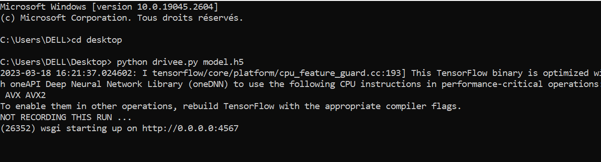

The good news is that the code « model » runs very well. It can perform deep learning and save the module.h5 that I used in the code « drivee ».

